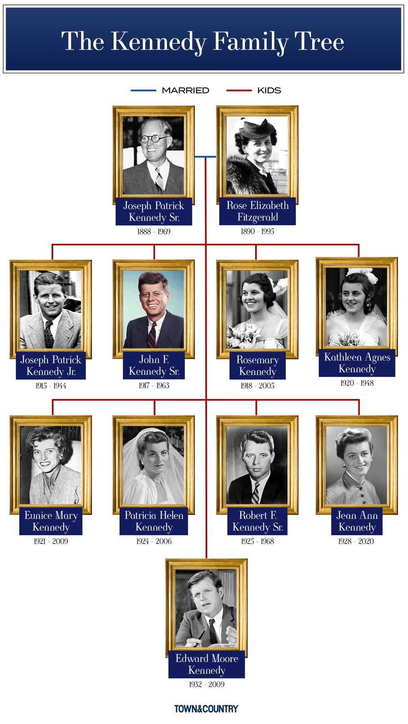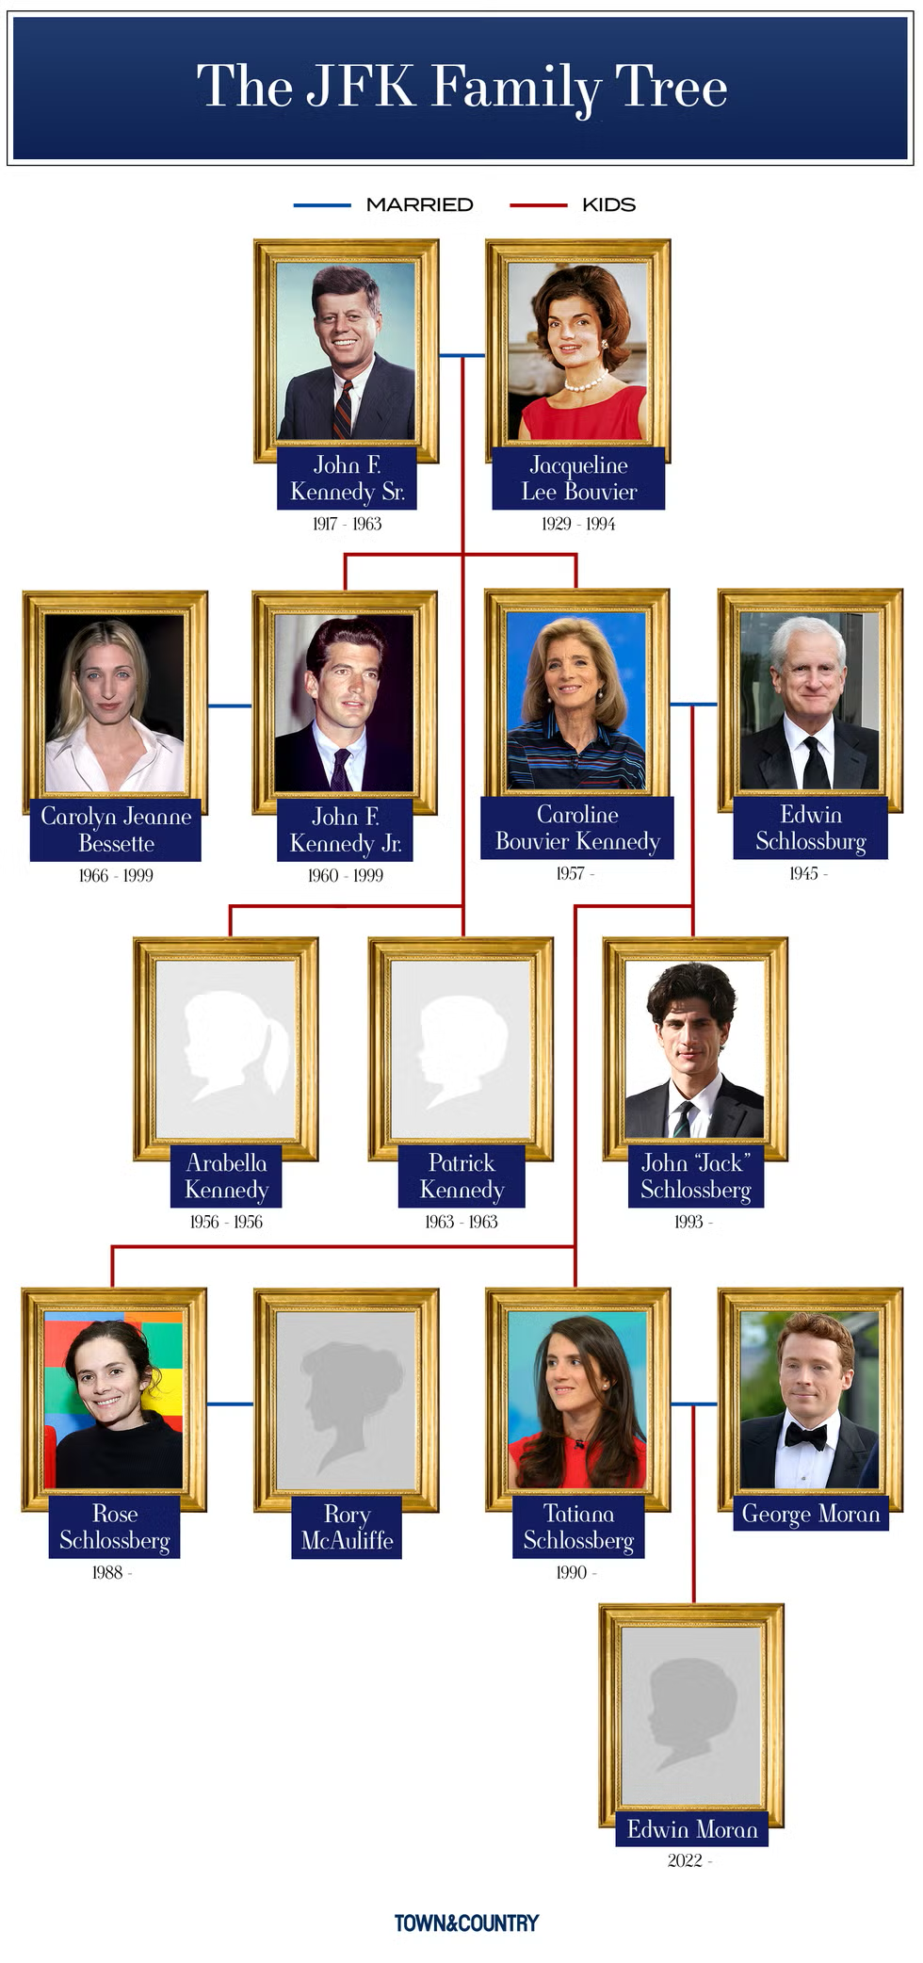

- Joseph Patrick Kennedy Sr. is Rose Elizabeth Fizgerald’s _______
- Rosemary Kennedy is Kathleen Agnes Kennedy’s ______________
- Joseph Patrick Kennedy Jr. is Josh F. Kennedy’s _____________
- Jean Ann Kendy is Rose Elizabeth Fizgerald’s ________________
- Edward Moore Kennedy is Joseph Patrick Kennedy’s __________
- Jacqueline Lee Bouvier is Rose Elizabeth Fizgerald’s __________
- Josh F. Kennedy is Edwin Schlossburg’s ____________________
- John “Jack” Schlossberg is Jacqueline Lee Bouvier’s __________
- Josh F. Kennedy is Carolyn Jeanne Bessette’s _______________
- Jacqueline Lee Bouvier is Rose Schlossberg’s ________________

1-son
2-sister
3-brother
4-daughter
5-son
6-daughter-in-law
7-son-in-law
8-grandson
9-father-in-law
10-grandmother

